Mackay School District No. 182

PERSONNEL 5740PF

Name: _____________________________________
Location: ___________________________________
Subject of Instruction: _________________________
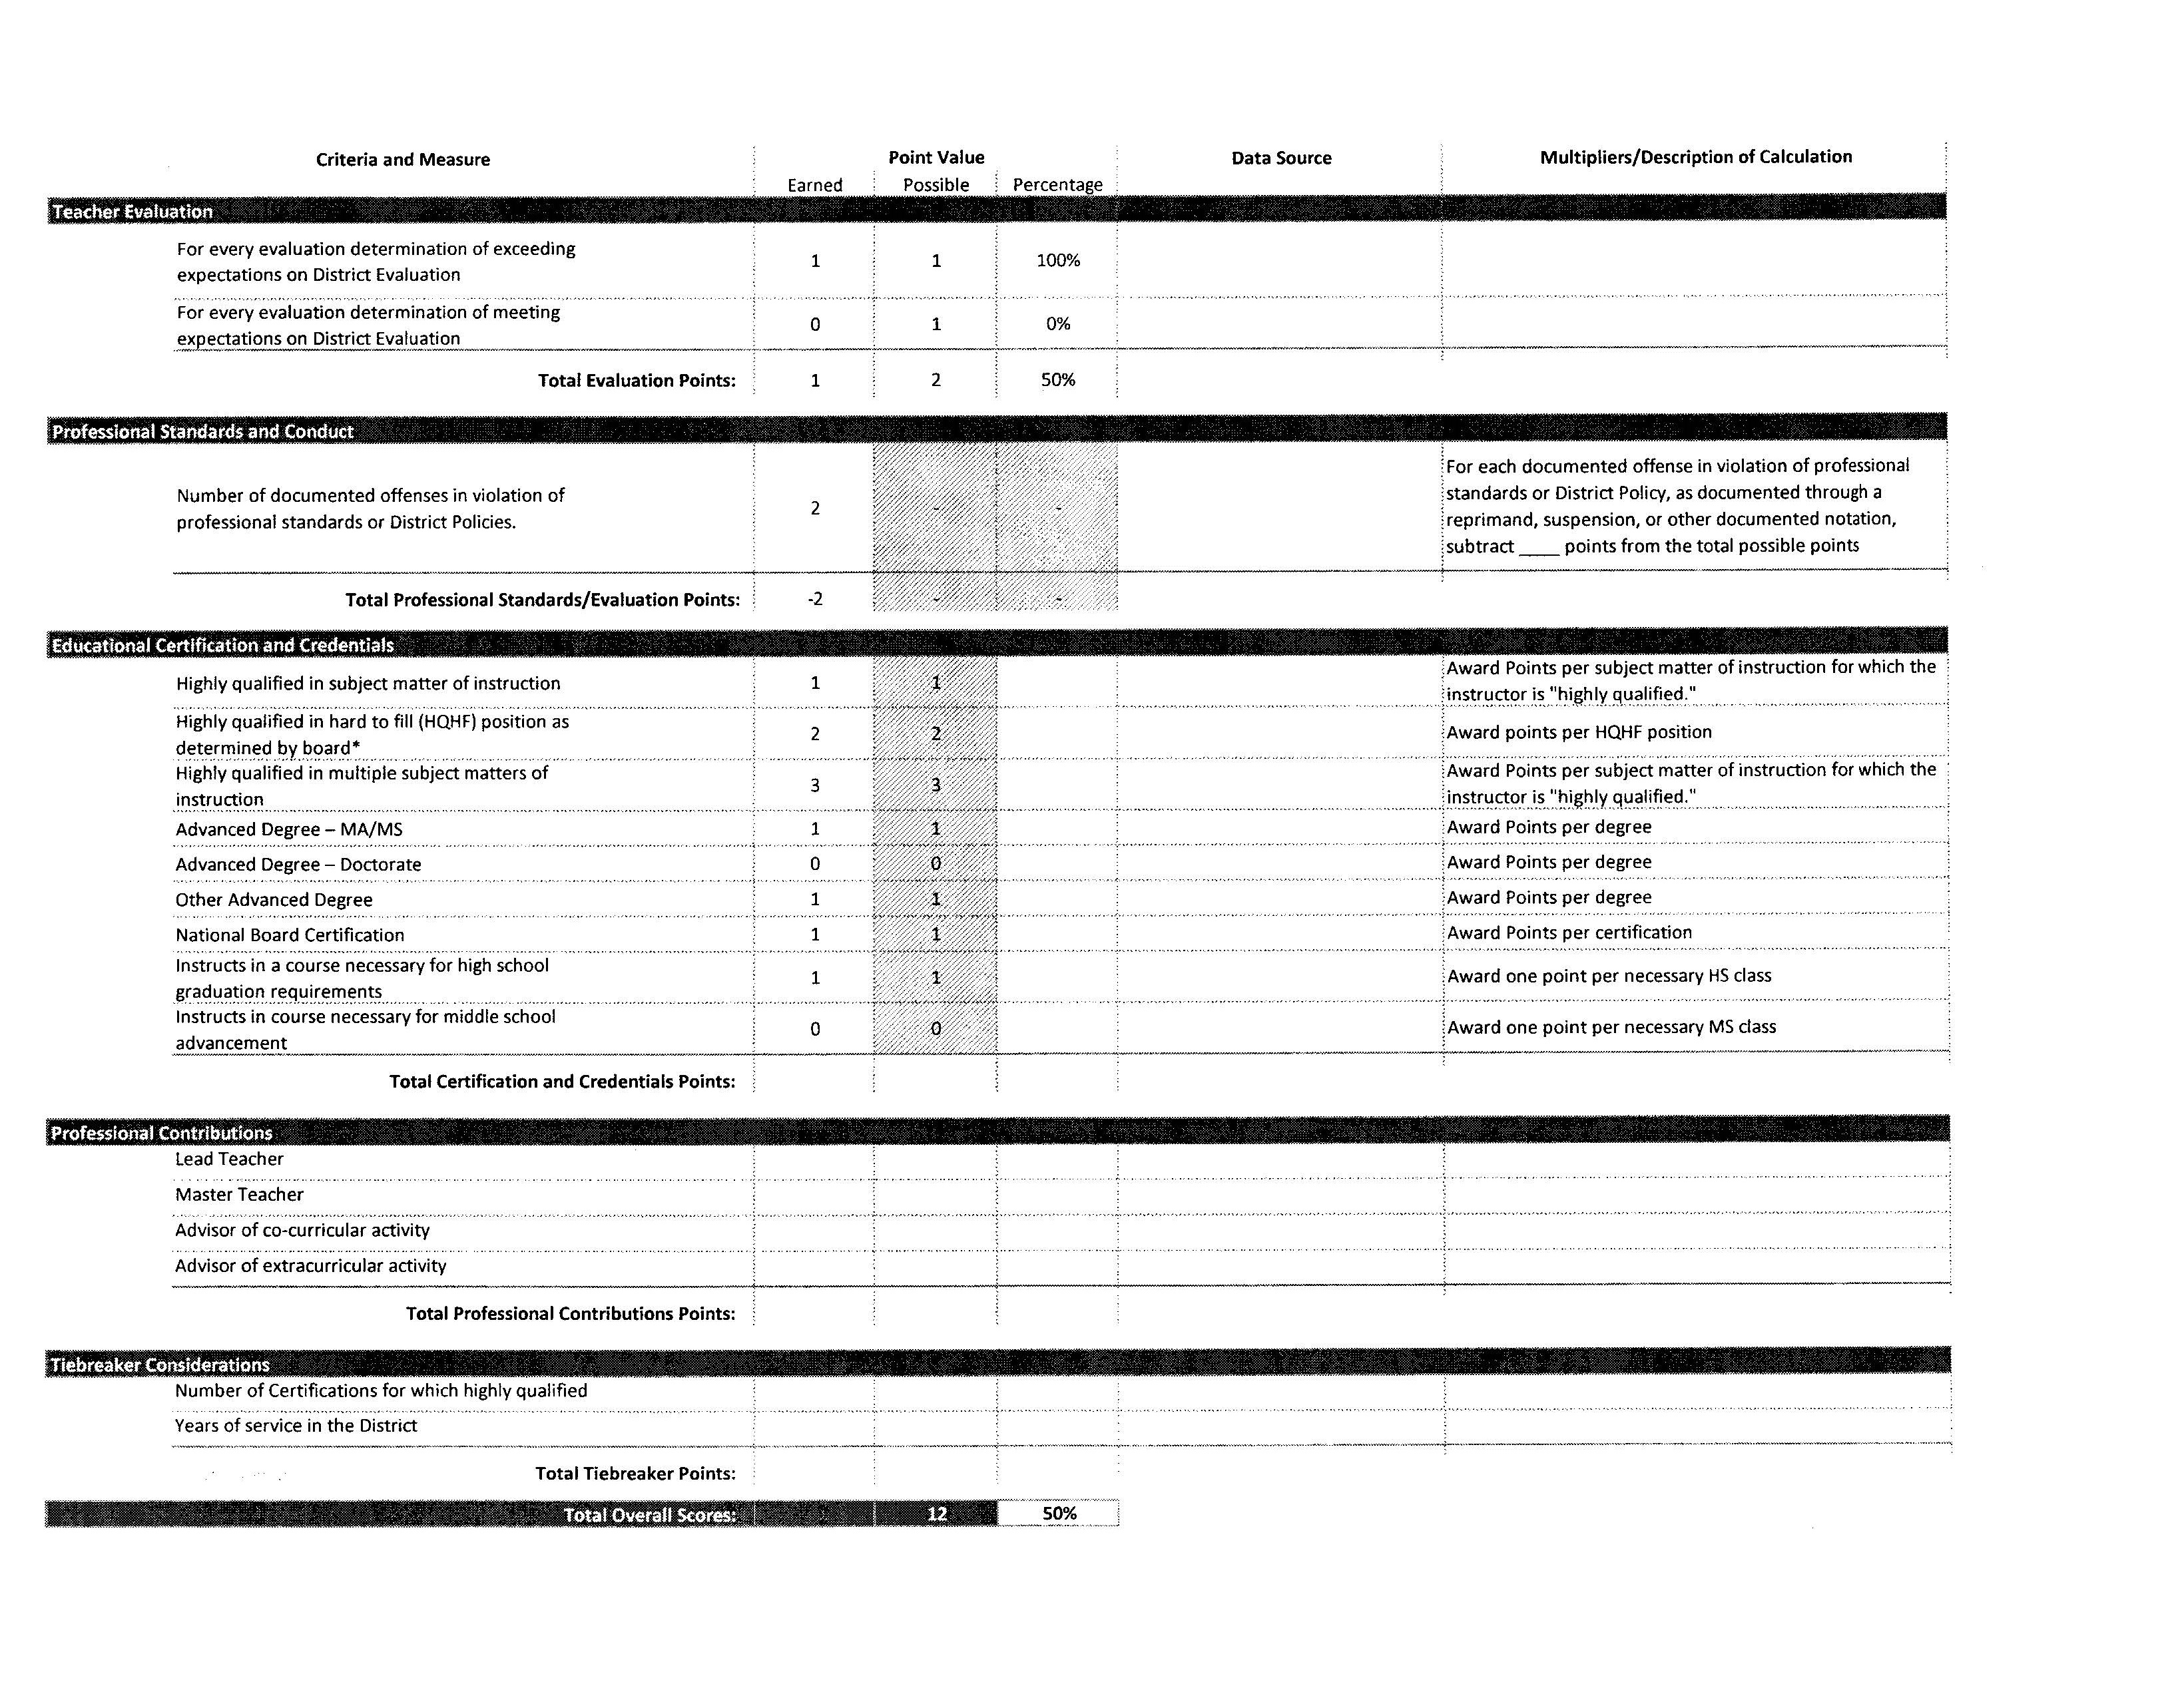

Form History:
Adopted on: June 11, 2012
Revised on: July 13, 2020

